[SQL Server Tutorial For Beginners (2022) | Microsoft SQL Server Tutorial | Class 11th 12th](https://www.youtube.com/watch?v=zt3cg1PgtII)

[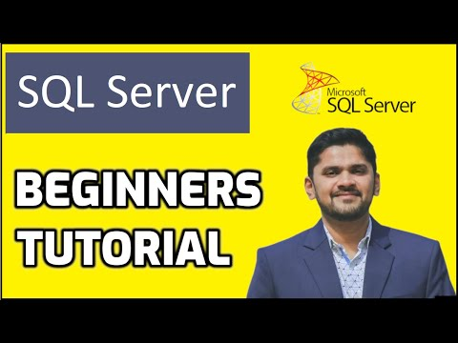](https://www.youtube.com/watch?v=zt3cg1PgtII)

**Video to install MongoDB**

https://www.youtube.com/watch?v=FwMwO8pXfq0